Photo Essay: American Slums

Student Name
Institutional Affiliation
Course Name
Submission Date

Photo Essay: American Slums
The idea of a slum in America sounds intrinsically farfetched, as many people know the US to be a land of equal opportunity and wealth. Nonetheless, the number of individuals living in high-poverty areas in America keeps on growing rapidly. Between the 2000 and 2013, the number of individuals located in high-poverty areas – aptly denoted as census tracts – continues to rise according to the government (Semuels, 2015).
Families with levels of income below that of federal poverty thresholds now stand at 40 percent or more, representing immense numbers that reach nearly 7.2 million according to recent census data analysis by the Rutgers University – Camden (Semuels, 2015). Such numbers represent the highest ever recorded of Americans living in neighborhoods with high poverty rates.
Such poverty rates are evident across America owing to sporadic migration witnessed among new middle-class minorities. Such individuals move to wealthier areas as seen by the move of middle-class Detroit residents to Oakland County; as a result, leaving the city’s core with little to no tax base. A permeation of such occurrences among others, which primarily stems from social class as a social structure, causes poverty and the subsequent sprawl of slums as seen in the photos below.
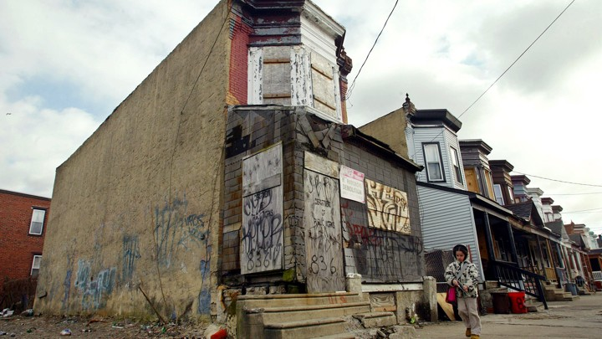
The above photo depicts the desolation in American slum areas (Stapleton, 2015). Apparently, the streets are uninhabited with little to no activity. Here, one can easily see the neglect the houses have faced due to blatant disregard in terms of the community welfare. As discussed above, such neglect stems from budget cuts due to a decrease in the overall tax base. Inherently, areas such as this witness minimal policing as well as community monitoring; thereby, resulting in negligence that portends occurrences such as graffiti as well as housing defects. One sees clearly the unfitness of setting up a business in such an area let alone having a family.
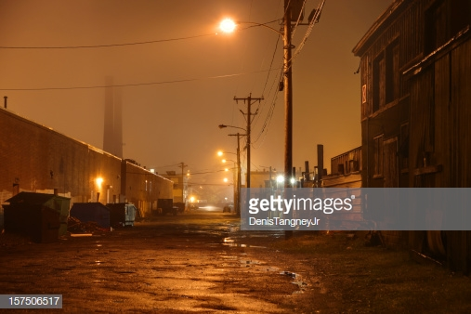
The image above similarly reinforces the desolation witnessed in the other photo (Getty Images, 2019). Intrinsically, this photo goes further to show the underlying security as well as welfare challenges faced in slum areas across America. As forgotten regions, such areas receive little to no funding attuned to the community. Due to the fundamental poverty experienced in such areas, community members do not have the means to alleviate neighborhood challenges. Such an area remains a magnet of poverty and crime. To add insult to injury, as seen in this photo, poor lighting results in the attraction of unruly citizens who may indulge in community vices such as excessive drinking and drug abuse.

References
Getty Images. (2019). Dark Urban Road [Image]. Retrieved from https://www.gettyimages.com/detail/photo/dark-urban-road-royalty-free-image/157506517
Semuels, A. (2015). The Resurrection of America's Slums. Retrieved from https://www.theatlantic.com/business/archive/2015/08/more-americans-are-living-in-slums/400832/
STAPLETON, S. (2015). The Resurrection of America's Slums [Image]. Retrieved from https://cdn.theatlantic.com/assets/media/img/mt/2015/08/RTR6HMO/lead_720_405.jpg?mod=1533691760

